Biology Name: _____________________________________________

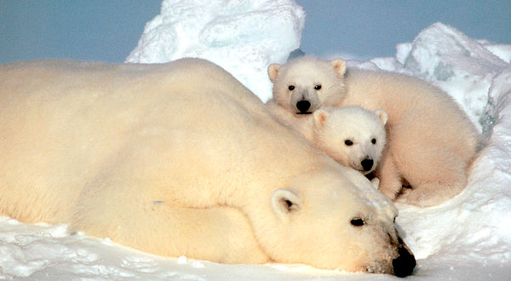
Investigating Mysteries of Polar Bears’ Ancestry With a DNA Lens
Polar bears, long thought to have branched off relatively recently from brown bears, developing their white coats, webbed paws and other adaptations over the last 150,000 years or so to cope with life on Arctic Sea ice, are not that recently descended from brown bears, scientists report.

Eeep! The introduction to an article above on polar bears does not demonstrate a clear understanding of the process of natural selection. This paragraph would not have scored well on one of Henshaw’s tests.

In the space given, please correct the author’s introduction. Demonstrate your knowledge of the mechanisms and process of natural selection. Use key terms or ideas that you have learned, such as: existing genetic variation, gene pool, gene frequency, selection

